Global Directory

Major Project - I
(August 2008 –Nov 2008)



Submitted By:
Saurav Gupta
Department of Mathematics and Computing
Indian Institute of Technology, New Delhi

Supervised By:
Prof. Rajesh Bhat
Department of Mathematics and Computing
Indian Institute of Technology, New Delhi

TABLE OF CONTENTS
1. ABOUT THIS DOCUMENT 1
1.1 Purpose 1
1.2 Objective 1
1.3 Scope 1
1.4 Organization of the Document 1
1.5 References 1
2. INTRODUCTION 2
2.1 Purpose of Project 2
2.2 Objectives of Project 2
2.3 Scope of Project 2
2.4 Scope Exclusions 2
2.5 Assumptions and Dependencies 2
2.6 Constraints 2
2.7 Important Considerations 3
2.8 Technology Stack 3
3. Global Directory 4
3.1 Introduction 4
3.2 Domains 4
3.3 Personal Identification Numbers (PINs) 4
4. Project Phases 6
5. Algorithms Analyzed 7
5.1 Requirement/Constraints 7
5.2 Algorithm Block Diagram 7
5.3 Algorithms Studied 8
5.4 Current and Future Scope 8
6. System Design 9
6.1 System Architecture 9
6.2 Technical Architecture – MVC Architecture 10
7. Database Design 12
7.1 Database Tables 12
7.2 Database Diagram 13
8. UML Diagrams 14
8.1 Use Case Diagrams 14
8.2 Sequence Diagrams 15
9. Screen Designs 17
9.1 Login Page 17
9.2 Master Page 17
9.3 Home Page 18
9.4 Create your account 19
9.5 Family Details 20
9.6 Contact Details 21
9.7 Offspring Details 22
9.8 Sibling Details 23
9.9 Births in Family after 1989 23
9.10 Deaths in Family after 1989 24
9.11 Other Details 25
9.12 Change Password 26
9.13 Forgot Password 26
9.14 Search a Member 27
9.15 Mail Box 28
9.16 Send Message 28
9.17 Send Mail 29
9.18 Approve/Reject Request 29
9.19 Error Page 31
10. Screenshots 32
10.1 Login Page 32
10.2 Header/Master Page 32
10.3 Home Page 33
10.4 Family Details 33
10.5 Sibling Details 34
10.6 Search a Member 34
10.7 Create new account 35
11. Secured Communications 36
11.1 Message to an Individual 36
11.2 Message to a Group 36
12. Applications 38
13. Salient Features 39
14. Conclusion 40

This document contains a total of 40 pages

ABOUT THIS DOCUMENT

Purpose

The purpose of this document is to provide the approach and the work accomplished in the assigned Project with the Title “Global Directory”.

Objective

The objectives of this document are:
- To provide the different algorithms analyzed during the execution of project.
- To provide the Architecture of the System.
- To establish the real-time use of the System.

Scope

The document is prepared, keeping in mind the above objectives.
This document restricts itself to –
- Algorithms Analyzed
- System Architecture
- UML and ER Diagrams

Organization of the Document

The structure of the document is as follows:
- Section 1 describes the purpose, objectives, scope and abbreviations used in this document.
- Section 2 gives the Introduction to the Project.
- Section 3 describes the Implementation Strategy
- Section 4 provides the pseudo codes for the Algorithms implemented and the implemented Strategy.
- Section 5 provides the observation/analysis of Algorithms
- Section 6 provides the scope for improvements

References

- VB 2005 with .NET 2.0 – By Bill Evjen, Bill Hollis, Bill Sheldon, Kent Sharkey

INTRODUCTION

Purpose of Project

The purpose of the Project is to create a directory of personal information of an individual, and too stored in Database in secured Environment. It provides a medium to contact your friends without sharing your contact details

Objectives of Project

The Key objectives are
- System to capture personal information of an Individual.
- System which can be used for Data Analysis or by Census.
- Secured data storage
- Secured Mechanism of contacting your friends and to send messages.

Scope of Project

The current scope is limited to
- Analyze the algorithms to store information in cryptic and compressed form in Database.
- Create forms to collect data.
- Provide Secured Mechanism to contact your friends

Scope Exclusions

The Scope of the project excludes
- Implementation of algorithm to store data in compressed form.
- Data Analysis

Assumptions and Dependencies

- Information entered by member is correct and accurate.
- System cannot check for the authenticity of the entered information.
- Regular Data verifications can be done to check for data authenticity.

Constraints

- There is no way to verify the information entered by the Member.

Important Considerations

Some of the important factors to be considered while implementing it:
- Secured Mechanism
- Complexity of Algorithms

Technology Stack

Hardware

Hardware Configuration : IBM PC’s 80 GB HDD 1 GB RAM
Operating System : Windows XP Professional

Software

Software : VS 2005 Developer Edition
Programming Language : VB.NET, .NET Framework 2.0 (ASP.NET)
Databases : SQL Server 2005
Tools : Effexis Sequence Diagram Editor

Global Directory

Introduction

The Global Directory is an online directory of personal information divided in Public and Private Domain made accessible to community of users. The users can add varied personal details, family details etc. The information is accessible to members only with valid Key Personal Identification Number (K-PIN) or User ID generated automatically from the personal information entered while signing-up.

We would generate two unique PINs for each member, one K-PIN based on some compulsory/key public domain information and other V-PIN (Variable Personal Identification Number) based on variable personal information in private domain.

This system allows user to contact other members via secured mechanism that is without sharing any personal information.

Domains

The complete information is divided into two domains

- Public Domain:
The Public Domain contains the Key information of an individual (like Name, DOB, etc...). The Key information is not updateable and can be shared with other member.

- Private Domain:
The Private Domain contains the variable information of an individual (like Sibling details, property details, etc...). This information is updateable and access to this information is restricted.
This information collected can be used for Analysis purposes like to find the average age of the community.

Personal Identification Numbers (PINs)

The PIN is an identification number generated for each member. For each member, following two PINs are generated:

- KPIN (Key PIN):
For the Public Domain information, the KPIN is generated based on following key information.
- Name, Fathers Name, Mothers Name, DOB

- VPIN (Variable PIN):
For the Private Domain information, the VPIN is generated based on the variable information of a member.
- Sibling Details, Offspring Details, Property Details etc...

Project Phases

To meet the project objectives within the given time frame, the project is implemented in the following phases:
- Study and Acquire Knowledge
- Analyzing Algorithms
- System Designing
- Implementation

A well-defined process is followed during each of these phases of the project. The essence of the process is a structured method of process control using checklists of activities with specific Entry criteria, Tasks, Validation procedures, and exit criteria (ETVX).

Study and Acquire Knowledge | Analyzing Algorithms | System Designing | Implementation
- Define Scope of Project  - Environment setup  - Study of different existing Compression and Encoding Techniques  - Learning Technologies – ASP.NET 2.0 and SQL Server 2005 | - Compare different algorithms  - Come-up with the appropriate algorithm for Compressed data storage | - Design Database Architecture  - Design Layout of Pages | - Create forms to collect data  - Implement the Algorithm.

Algorithms Analyzed

As there is a need to compress the database information to reduce the data storage and to provide the high data security, so to achieve that several existing algorithms are studied and analyzed to for their appropriateness. The algorithms requirement/constraints are highlighted below.

Requirement/Constraints

As per the requirement, we need to perform the compression and encoding of the data and to store all the information in cryptic format.
But data storage in cryptic format is not the only constraint. For generating KPIN, we need to restrict the length of the KPIN (Username) also as the member has to remember and enter it on the portal to login into Global Directory. So the length of the KPIN is restricted to 10 so that all alphabets of KPIN are enterable from keyboard and can be remembered easily.
Considering that we have to generate 10 character KPIN, we can store 36¹⁰ members in the directory and if required, we can increase the characters limit.

Algorithm Block Diagram

To perform the operation specified in the above section, we decided that we will work on the strategy depicted in the below figure.

Information
Compression
Encoding
KPIN / VPIN
PIN Generation
Decompression
Decoding
Information regeneration from KPIN
Information

Algorithms Studied

Several existing algorithms are studied to achieve the Compression/Encoding of data and to generate the PINs but each of them has some limitation. Few are mentioned below:
- During compression, there is some loss of information.
- The characters representing the compressed form are not enterable characters
- The Length of the encoding technique used has no limit on length of characters.
- The Length of compressed string may vary with the data and can cross our initial limit of 10 characters of KPIN.

Under the constraints mentioned above, we decided to generate our own algorithm to generate the PIN IDs.

Current and Future Scope

During the implementation of Major Part – I, we analyzed the existing algorithms and found that the existing algorithms approach will not work. So we worked on to come-up with our own algorithm for the same. Under the time constraints to create the Global Directory portal, we didn’t come up the finalized algorithm. So the implementation of the algorithm can be taken up as Major Part – II.

System Design

System Architecture

Database
Client Server –
Web Browser

Web Server
Request for page
Request for data
Received Data
HTML Page with required contents
Client-Server Model
The Client-Server software architecture model distinguishes client systems from server systems, which communicate over a computer network. A client-server application is a distributed system comprising both client and server software. A client software process initiates a communication session, while the server waits for requests from any client.
Client/server describes the relationship between two computer programs in which one program, the client, makes a service request from another program, the server. Each instance of the client software can send data requests to server. In turn, the servers can accept these requests, process them, and returns the requested information to the client.
This type of architecture is referred to as two-tier. The two tier architecture means that the client acts as one tier and application in combination with server acts as another tier.
A Web Browser is a client program at the user computer that may access information at any web server in the world. It allows a user to quickly and easily access information provided on many Web pages. Web browsers format HTML information for display, so the appearance of a Web page may differ between browsers.

Characteristics of a Web browser
- Initiates requests
- Waits for replies
- Receives replies
- Usually connects to a small number of servers at one time
Typically interacts directly with end-users using a graphical user interface
A Web Server is a computer program that is responsible for accepting HTTP requests from W, and serving them HTTP responses along with optional data contents, which usually are web pages such as HTML documents and linked objects (images, etc.).

Characteristics of a server

Never initiates requests or activities

Waits for and replies to requests from connected clients

A server can interact with Database to fetch data. We can have a separate Database Server for data access. A database server is a computer program that provides database services to other computer programs or computers, as defined by the client-server model.

The Client-Server architecture has the following benefits:
- In most cases, a client-server architecture enables the roles and responsibilities of a computing system to be distributed among several independent computers that are known to each other only through a network. This creates an additional advantage to this architecture: greater ease of maintenance.
- All the data is stored on the servers, which generally have far greater security controls than most clients.
- Since data storage is centralized, updates to that data are easier to administer.
- It functions with multiple different clients of different capabilities.

To create/update your account from your computer, a web browser client program in your computer forwards your request to a web server program. That program may in turn forward the request to its own database client program that sends a request to a database server to retrieve information. The information is returned to the client, which in turn serves it back to the web browser client in your personal computer, which displays the information.

Technical Architecture – MVC Architecture

The goal of the MVC design pattern is to separate the application object (model) from the way it is represented to the user (view) from the way in which the user controls it (controller).
- Model: The model object knows about all the data that need to be displayed. It is model who is aware about all the operations that can be applied to transform that object. It only represents the data of an application. The model represents enterprise data and the business rules that govern access to and updates of this data. Model is not aware about the presentation data and how that data will be displayed to the browser.
- View: The view represents the presentation of the application. The view object refers to the model. It uses the query methods of the model to obtain the contents and renders it. The view is not dependent on the application logic. It remains same if there is any modification in the business logic. In other words, we can say that it is the responsibility of the view's to maintain the consistency in its presentation when the model changes.
- Controller: Whenever the user sends a request for something then it always go through the controller. The controller is responsible for intercepting the requests from view and passes it to the model for the appropriate action. After the action has been taken on the data, the controller is responsible for directing the appropriate view to the user. In GUIs, the views and the controllers often work very closely together.

The MVC architecture has the following benefits:
- Multiple views using the same model: The separation of model and view allows multiple views to use the same enterprise model. Consequently, an enterprise application's model components are easier to implement, test, and maintain, since all access to the model goes through these components
- Easier support for new types of clients: To support a new type of client, you simply write a view and controller for it and wire them into the existing enterprise model.
- Clarity of design: By glancing at the model's public method list, it should be easy to understand how to control the model's behavior. When designing the application, this trait makes the entire program easier to implement and maintain.
- Efficient modularity: The design allows any of the components to be swapped in and out as the user or programmer desires - even the model! Changes to one aspect of the program aren't coupled to other aspects, eliminating many nasty debugging situations. Also, development of the various components can progress in parallel, once the interface between the components is clearly defined.
- Ease of growth: Controllers and views can grow as the model grows; and older versions of the views and controllers can still be used as long as a common interface is maintained.
- Distributable: With a couple of proxies one can easily distribute any MVC application by only altering the startup method of the application.

Database Design

Database Tables

Table Name | Purpose
MemberInfo | This table contains basic information of Member. (Name, Age)
ContactDetails | This table contains the contact information of member (Address, Contact No., Email Id)
FamilyDetails | Contains parental details: Father’s/ Mothers Name
SiblingDetails | Contains Sibling details
OffspringDetails | Contains Offspring details
Birthsafter1989 | Contains information of Birth in Family after 1989
Deathsafter1989 | Contains information of Death in Family after 1989
PropertyDetails | Add Property details of member
OtherDetails | Add other member details like Education, Employment details
MailList | List of all mails sent from one member to another mail via secured mechanism.
RequestforPublicMessage | Stores Request pending/answered by administrator for sending message to a Group
ArchivedRequests | Archived Messages Approved/Rejected by administrator
AdminAccess | Provide Administrator access to member for approval/rejection of request or to archive requests

Database Diagram

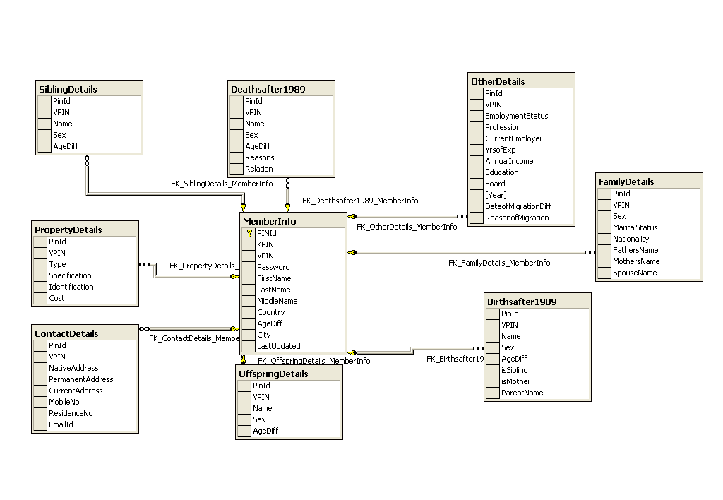

UML Diagrams

The Unified Modeling Language (UML) is a standard language for specifying, visualizing, constructing, and documenting the artifacts of software systems, as well as for business modeling and other non-software systems. The UML represents a collection of best engineering practices that have proven successful in the modeling of large and complex systems. The UML is a very important part of developing objects oriented software and the software development process. The UML uses mostly graphical notations to express the design of software projects.

Use Case Diagrams

User
Create an account
Update your personal Details
Search your friend
Send Message to an Individual
Send Message to a Group
Get KPIN

Sequence Diagrams

The interaction between client and server is often described using sequence diagrams. Sequence diagrams are standardized in the Unified Modeling Language.

Create an Account

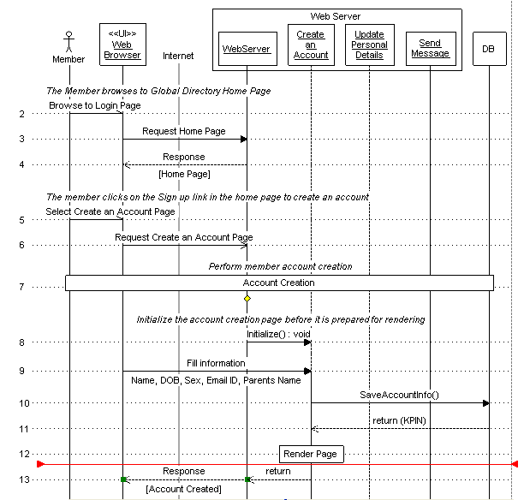

Update your personal Details

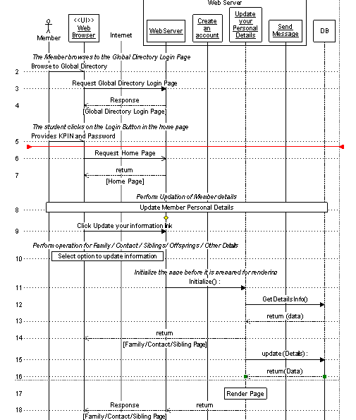

Screen Designs

Login Page

Functionality
This page allows you to login into the Global Directory to access the personal information and to send Message to a group or to contact your friends.

The links available on the screen:

- Are you stuck?
If you forgot your password, you can click this link to recover your password. This will send your password to your Email Id.

- Sign up
A new member can join the Global Directory by providing the key information about him.

File Name:
GlobalDirectory.aspx

Tables used
S.No. | Table | Operation
 | MemberInfo | To check for the existence of a member

Validations
S.No. | Condition | Message
 | If Member has provided incorrect Username/password | *Invalid KPIN or Password

Assumptions and dependencies:
None

Master Page

Functionality
This page shows a Header on every page of the site. This shows the Name and KPIN of the member at the top of the page. Also provides the link to Log out from the Global Directory.
The Member information and Logout Link gets displayed in Header only if a Member is logged in the system.

The links available on the screen:

- Home
If you are on any page of site, then by clicking this link you can move to Home page.
- Privacy Practices
This highlights the privacy practices followed by owners of Global Directory to secure the information.
- Providers
It provides Information on Owners and establishing the concept behind Global Directory.
- Contact Us
It provides contact Information of Global Directory administrators and owners.
- Log out
It allows you to logout from Global Directory.

File Name:
Masterpage.Master

Tables used
S.No. | Table | Operation
 | MemberInfo | To show information of Member

Validations
S.No. | Condition | Message

Assumptions and dependencies:
None

Home Page

Functionality
This page shows your First/Middle/Last Name and Date of Birth as this information is not updateable. Also provides you an option to Search your friend and to update your personal details.

The links available on the screen:
- Update your Information
This link provides you an access to update your family details, contact details and so on.
- View your Mail Box
It allows you to view the mails sent by other Members of the group via the secured mechanism.
- Search a Member
This allows you to search your friend who is also the member of the Directory.
- Change Password
You can change your password. No option to change your KPIN/Username.
- Admin
This link is visible only to the administrator of Global Directory to approve/reject request to send a message to a group.

File Name:
Memberinfo.aspx

Tables used
S.No. | Table | Operation
 | MemberInfo | To show Member details
 | AdminAccess | To check for Administrator accesses

Validations
S.No. | Condition | Message

Assumptions and dependencies:
None

Create your account

Functionality
This page allows you to create your account in the Global Directory by providing some basic information (Name, DOB, Sex, Email ID, and Parents Name).
When you click the Submit button to create account, then you will get a confirmation page (shows all information entered on previous page). If you click “Yes”, the your information will get saved and your KPIN is generated and an email is also send with details of KPIN and Password , and if you click “No”, you will be send back to the previous page to correct the information.

File Name:
MemberForm.aspx

Tables used
S.No. | Table | Operation
 | MemberInfo | To save Member details
 | FamilyDetails | To save Family Details (Parents information)
 | ContactDetails | To save contact information
 | OtherDetails | No information added. A blank record is created.

Validations
S.No. | Condition | Message
 | Length of First/Middle/Last Name, Parents’ Name < 2 | Initials not allowed. Use full name
 | First/Middle/Last Name, Parents’ Name contains characters other than Alphabets and space | Use only Alphabets and space
 | First/Last Name, Parents’ Name are not specified (Middle name is not Mandatory) | Please specify First/Last Name
 | Length of Name, Parents’ Name > 30 | Name can not have length greater than 30.
 | DOB is not correctly specified | Incorrect Date. Please specify correct Date of Birth
 | Email ID is in incorrect format | Incorrect EmailId. Please specify correct Email Id.
 | Length of Password < 8 | Password should be of atleast 8 characters.
 | Password is not equal to Confirm Password | Password should be same.

Assumptions and dependencies:
- Information entered by member is correct and accurate.
- System cannot check for the authenticity of the entered information.
- Regular Data verifications can be done to check for data authenticity.

Family Details

Functionality
This page allows you to provide your family details. You can provide following information:
- Parents Name
- Marital Status
- Spouse Name

If you select the marital status as married, then only you can specify the Spouse Name.

Note: On all the screens where you can update your personal information, there is a drop- down list from where you can select the type of information which can updated. The options available are
- Family Details
- Contact Details
- Sibling Details
- Offspring Details
- Deaths in family after 1989
- Births in family after 1989
- Other Details

File Name:
FamilyDetails.aspx

Tables used
S.No. | Table | Operation
 | FamilyDetails | To update the Family details

Validations
S.No. | Condition | Message
 | Validation on Father’s/Mother’s and Spouse Name | Validations and messages are same as defined in Name validation while creating an account.

Assumptions and dependencies:
None

Contact Details

Functionality
This page allows you to provide the contact details. You can provide following information:
- Native Address
- Permanent Address
- Current Address
- Mobile and Landline Phone number
- Email ID
If all the three addresses are same, then you don’t have to mention same address again. You need to provide information once and copy the same address by checking the checkbox.

File Name:
contactdetails.aspx

Tables used
S.No. | Table | Operation
 | Contact details | To store updated contact information

Validations
S.No. | Condition | Message
 | The length of Address < 70 | Address can not have length greater than 70.
 | The city, state and Country should contain only alphabets | It can have Alphabets and space only
 | Validation on Street | Street can have allows Alphabets, space and (-), (/), (\), (,).
 | Validation on Phone number | Mobile/Landline Number can have digits only.

Assumptions and dependencies:
None

Offspring Details

Functionality
This page allows you to provide the Offspring details. You can provide following information assuming each member will have a separate account.
- Name
- Sex
- Date of Birth

This page also shows the existing records saved by you and also provide the feature of adding/deleting the records.

File Name:
OffspringDetails.aspx

Tables used
S.No. | Table | Operation
 | MemberInfo | To update the last updated date information.
 | OffspringDetails | To store the updated Offspring Details

Validations
S.No. | Condition | Message
 | Validation on Name | Note: The checks which are applied on Name while creating the account are applicable.
 | DOB should be correct. | Incorrect Date. Please specify correct Date of Birth

Assumptions and dependencies:
None

Sibling Details

Functionality
This page allows you to provide the Sibling details. You can provide following information assuming each member will have a separate account.
- Name
- Sex
- Date of Birth

This page also shows the existing records saved by you and also provide the feature of adding/deleting the records.

File Name:
SiblingDetails.aspx

Tables used
S.No. | Table | Operation
 | MemberInfo | To update the last updated date information.
 | SiblingDetails | To store the updated Sibling Details

Validations
S.No. | Condition | Message
 | Validation on Name | Note: The checks which are applied on Name while creating the account are applicable.
 | DOB should be correct. | Incorrect Date. Please specify correct Date of Birth

Assumptions and dependencies:
None

Births in Family after 1989

Functionality
This page allows you to provide details of Births in Family after 1989. You need to specify Name, Sex, Date of Birth and Parents Name. Here the parent could be your sibling also as you are storing information of all births in your family and not only of your child.

This page also shows the existing records saved by you and also provide the feature of adding/deleting the records

File Name:
BirthDetails.aspx

Tables used
S.No. | Table | Operation
 | MemberInfo | To update the last updated date information.
 | Birthsafter1989 | To store updated details of Births in Family after 1989
 | SiblingDetails | To show Siblings in Parents Name
 | OffspringDetails | To show Offspring’s in Parents Name

Validations
S.No. | Condition | Message
 | Validation on Name | Note: The checks which are applied on Name while creating the account are applicable.
 | DOB should be correct. | Incorrect Date. Please specify correct Date of Birth

Assumptions and dependencies:
None

Deaths in Family after 1989

Functionality
This page allows you to provide details of Deaths in Family after 1989. You need to specify Name, Relation, Date of Birth and Reason and Date of death. Here the parent could be your sibling also as you are storing information of all deaths in your family and not only of your child.

This page also shows the existing records saved by you and also provide the feature of adding/deleting the records.

File Name:
DeathDetails.aspx

Tables used
S.No. | Table | Operation
 | MemberInfo | To update the last updated date information.
 | Deathsafter1989 | To store updated details of Deaths in Family after 1989
 | SiblingDetails | To show Siblings in Parents Name
 | OffspringDetails | To show Offspring’s in Parents Name

Validations
S.No. | Condition | Message
 | Validation on Name | Note: The checks which are applied on Name while creating the account are applicable.
 | DOB should be correct. | Incorrect Date. Please specify correct Date of Birth

Assumptions and dependencies:
None

Other Details

Functionality
This page allows you to store following information apart from the basic information.
- Migration Details
If you have migrated from your native place, then you can provide the Reason and date of Migration.
- Education Details
You can provide the Highest Degree, Passing Board/University, Year of Passing and Employment Status. If you are employee, then provide the professional details.
- Professional Details
You can provide information about your current employer like your income, current employer, profession, Years of Experience
- Property Details
You can update your property details. The property details are classified as per the property type: Agricultural, Residential, Commercial and Movable and provide property Specifications, Identification and cost.

File Name:
OtherDetails.aspx

Tables used
S.No. | Table | Operation
 | MemberInfo | To update the last updated date
 | OtherDetails | To update the Education, Migration and Professional details.
 | PropertyDetails | To update the Property details.

Validations
S.No. | Condition | Message
 | Check for Date of Migration | Incorrect Date. Please specify correct Date of Migration.
 | Check for Reason of Migration | It can have Alphabets, space, (.) and Round brackets.
 | Check for Highest Degree | It can have Alphabets, space, (.) and Round brackets.
 | Check for Year of Passing | Year of Passing is a numeric field
 | Check for Company | Company can have Alphabets, space, (.) and Round brackets.
 | Check for Year of Experience | Year of Experience is a numeric field

Assumptions and dependencies:
None

Change Password

Functionality
This page allows you to change password.

File Name:
changepassword.aspx

Tables used
S.No. | Table | Operation
 | MemberInfo | To save the updated password.

Validations
S.No. | Condition | Message
 | Length of Password < 8 | Password should be of at least 8 characters.
 | Password is not equal to Confirm Password | Password should be same.
 | The Username/KPIN should be correct. | Invalid KPIN. Please specify correct Username/KPIN

Assumptions and dependencies:
None

Forgot Password

Functionality
This page allows you to retrieve your password based on your KPIN. This will send you an email with your password. If you forgot your KPIN, then you need to send an email to System Administrator to get the KPIN.
The page opens up in a new window as a pop-up.

File Name:
Forgotpassword.aspx

Tables used
S.No. | Table | Operation
 | MemberInfo | To retrieve password.

Validations
S.No. | Condition | Message

Assumptions and dependencies:
- Member should know his Username/KPIN.

Search a Member

Functionality
This page allows you to search a member to show list of all members based on the specified filter criteria. You can define the query with maximum of three clauses and the filter criteria can be varied. The filer criteria/field can be First Name, Last Name, City, Country etc.
When you click the Search button, you can view list of members.

Sample Query which can be specified by a member
FirstName = “Saurav” AND
LastName = “GUPTA” OR
City=”Delhi”

File Name:
SearchDirectory.aspx

Tables used
S.No. | Table | Operation

Validations
S.No. | Condition | Message

Assumptions and dependencies:
None

Mail Box

Functionality
This page allows you to view the Mails sent to you by any other member. You can view the Name, City and country of the member and also the subject of the mail sent at your personal Email ID. This screen shows just the information about the person who sent you the email via Global directory.
You can reply via global directory only to his email by clicking the Hyperlink for that person.

You can delete the records from Inbox also

File Name:
InBox.aspx

Tables used
S.No. | Table | Operation
 | MemberInfo | To retrieve the Name based on KPIN
 | MailList | To retrieve the list of all mails received.

Validations
S.No. | Condition | Message

Assumptions and dependencies:
None

Constraints
- You can only reply to the mail via Global Directory only
- You cannot view your sent folder.

Send Message

Functionality
This page allows you to send message to a friend/Group listed. This screen shows list of all the members based on the search criteria defined in the previous screen. The list shows Name, city and country of the member.
You can send message to the complete group by clicking the “Send message to Group” Button.

File Name:
Displaymembers.aspx

Tables used
S.No. | Table | Operation
 | Information passed from previous screen in session

Validations
S.No. | Condition | Message

Assumptions and dependencies:
None

Send Mail

Functionality
This page allows you to send email to the selected member. You need to provide the Subject and the Message body and when you click send, an email is sent to a member from GlobalDirectory.com, thus hiding the sender’s information. If you are sending message to a group, then it will move to the basket of administrator for approval. If approved, then email is sent to the Group.

File Name:
SendMail.aspx

Tables used
S.No. | Table | Operation
1) | MailList | It stores the mail information

Validations
S.No. | Condition | Message

Assumptions and dependencies:
None

Approve/Reject Request

Functionality
This page allows administrator to approve/reject the request for sending message to a Group. The approval functionality is added to stop sending malicious messages to a Group.

You can view all the Requests which are pending for approval and also the approved/rejected requests. To avoid showing the complete list of requests, an administrator can archive the approved/rejected requests done before a particular date.

Pending request Section
This shows list of all Pending requests for approval/rejection of messages. You can view the body of the message by clicking the subject link. The Approval/Rejection button available for each pending record

Tables used
S.No. | Table | Operation
 | MemberInfo | To get Member detail for the user who has raised the request.
 | RequestforPublicMessage | To show all pending request and to update record after approval/rejection.

Validations
S.No. | Condition | Message

All request Section
This shows list of all requests pending for approval/rejection or approved/rejected status. You can view the body of the message by clicking the subject link. Also provides the link to archive the approved/rejected records based on the selected date.

Tables used
S.No. | Table | Operation
 | MemberInfo | To get Member detail for the user who has raised the request.
 | RequestforPublicMessage | To show all pending request and to update record after approval/rejection.
 | ArchivedRequests | To store the archived approved/rejected records

Validations
S.No. | Condition | Message

File Name:
Admin.aspx

Assumptions and dependencies:
- The records are periodically archived done by administrator. This is a Manual process.

Error Page

Functionality
If an error due to any error, then you are directed to this page and it shows you the following error message ” An unexpected error has occurred, please try again and if problem persists, contact System Administrator for further assistance.”. This allows you to send message to System administrator by sending an email notification.

Tables used
S.No. | Table | Operation

Validations
S.No. | Condition | Message

File Name:
Errors.aspx

Assumptions and dependencies:
None

Screenshots

Login Page

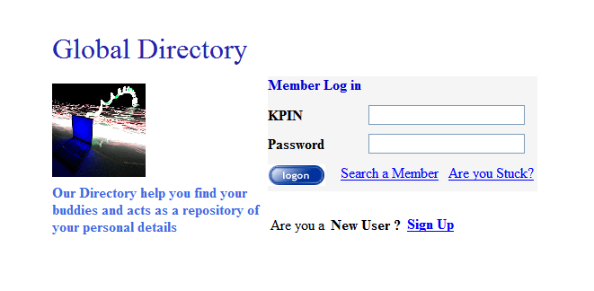

Header/Master Page

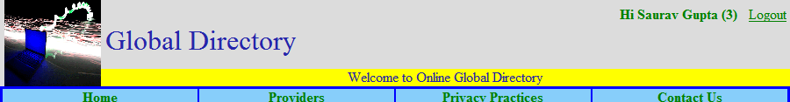

Home Page

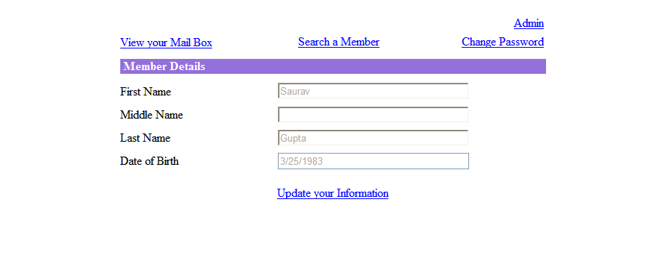

Family Details

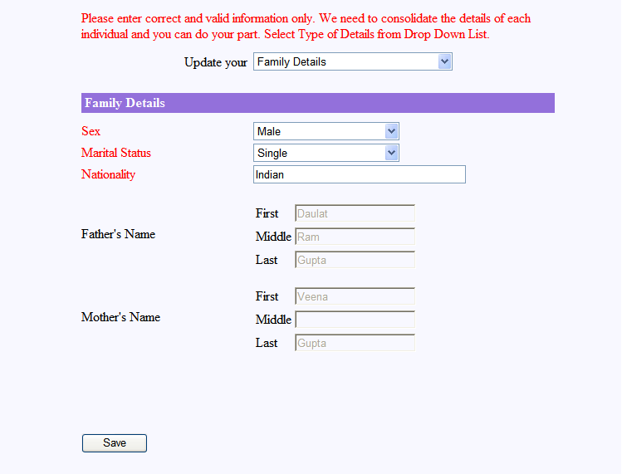

Sibling Details

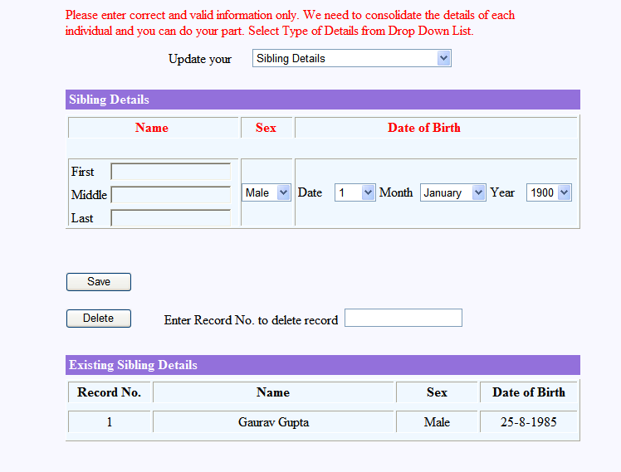

Search a Member

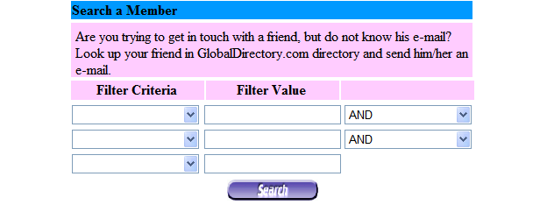

Create new account

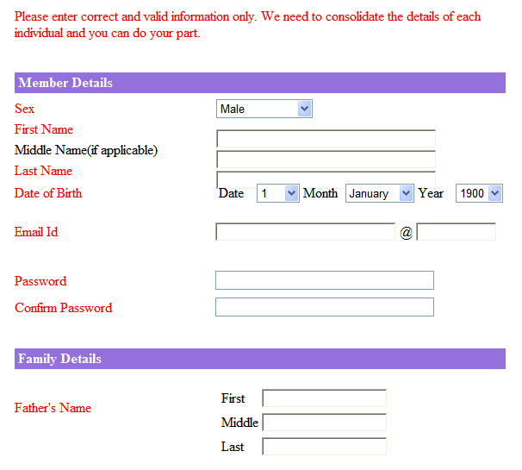

Secured Communications

The Global Directory provides a platform to contact your friends or to search a member based on different filter criteria’s like First Name, Last Name, City and Country. Under the internet age, Email is the easiest and the fastest way of communication. The best part of this communication is that it is totally secured, that is all communication takes place under the secured environment of Global Directory.

You can send a message/email to another member via Global Directory and you need not to share any Contact information that is even without sharing your personal Email IDs. The Global Directory also provides you an option to send a message to a group, equivalent to broadcasting a message.

Message to an Individual

For sending a message to an individual, you need to search that member on the portal based on the defined criteria’s. When you search a member, then you can see the list of all members meeting the search criteria. On the same page, you will find a link to send a message to the selected member.

Now provide the Subject and Message body of the Email to be sent to another member. When you click the send button, then an email is sent to the member with the TO field as “GlobalDirectory.com” and also the entry gets appeared in the Inbox of the other member so that the other member can reply the email.

The Email sent by other member via Global Directory portal, will come to your personal mail box but you cannot reply to that Email as the mail was sent by GlobalDirectory.com But you can reply to the email by visiting your Inbox on the portal. Your Inbox will display the Name, city and country of the sender, Mail received date and the Subject of the mail so that you can identify the mail for reply. Now select the Mail to be replied and provide the subject and message and send reply to the member

Note: For sending mail to an individual, no approval from administrator is required.

Message to a Group

Another use of Global Directory is broadcasting message to a Group based on the filter criteria.
For sending a message to group, you need to search that member on the portal based on the defined criteria’s. When you search, then you can see the list of all members meeting the search criteria. On the same page, you will find a button “Send message to Group” to send a message to all the members.

Now provide the Subject and Message body of the Email to be sent to another member. When you click the send button, then your request is sent to Administrator for approval. The approval level is added to avoid/restrict users from sending any malicious or useless messages. If an administrator approves the request, then an email is sent to the member list with the TO field as “GlobalDirectory.com” and also the entry gets appeared in the Inbox of the members so that the other member can reply to the email if required.

The broadcasted message sent via Global Directory portal, will come to your personal mail box but you cannot reply to that Email as the mail was sent by GlobalDirectory.com But you can reply to the email by visiting your Inbox on the portal. Your Inbox will display the Name, city and country of the sender, Mail received date and the Subject of the mail so that you can identify the mail for reply. Now select the Mail to be replied and provide the subject and message and send reply to the sender.

Note: For sending mail to a group, an approval from administrator is required.

Applications

The Global Directory designed is just the beginning of era as the portal can be enhanced so that we can use the portal for several different purposes and can be prove to be an asset. Few of the applications or area of usage is defined as

- Census:
The data collected can be used by the Government of India for census purposes. Under the internet age, once the data is manually collected and can be tracked for lifetime and also provide a medium for the members to update it regularly.
- Data Analysis:
You can also use the data collected for analysis purposes like to find the average age of the community, the literacy rate, the Employment Status or the standard of living.
- Communication:
The secured mechanism allows you to broadcast message to a group/community under emergency circumstances.
- Contact a friend:
It also provides you a feature to find your lost friend and establishing contact with him by searching over the portal. Even if you have migrated from one place to another but still you can be in touch with your friend as it searches based on your native place.
- The portal can be used to generate a report of all your ancestors and can generate the family graph.

Salient Features

- Requires less data storage space
Considering that we are planning to store the information in compressed format, less data space is required in the database.

- Provides High data security
The Access to personal data is restricted by KPIN and password and can only be updated by the member only. The communication via a secured mechanism ensures that no personal/contact details are disclosed to establish relationship.

- Scalable
The Global Directory portal can be extended up to any level and data can be collected for Community, society, city or country.

- Available Online
Under the internet, the best way to enter/provide details online. You can provide all required details just sitting at home and within the reach of every individual

- Easy to use
The portal is very easy to use as appropriate messages and basic data information is collected. With the enhanced features, the Help functionality can be added to make it easier for user.

Conclusion

The project Global Directory is completed with satisfaction. The algorithm for KPIN generation still requires attention as it doesn’t provide the high level of compression as expected. But the applications and real time usage of the portal make it very useful for every group and will find it usage in every field.

